Southwick Fire Department
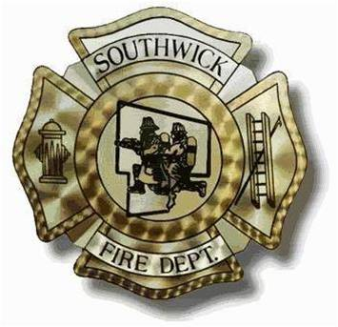
15 Depot Street
Southwick Massachusetts, 01077

Application for Membership

_____________________________ _____________________________ ______ _________________________
Last Name First Name MI Phone
______________________________________________________________________________________________
Present Address (City, State, Zip Code)
______________________________________________________________________________________________
Mailing Address (City, State, Zip Code)
E Mail Address : _____________________________________ Cell Phone : _____________________________

High School: ___________________________________________ Graduate? Yes____ No____

___________________________________________
City, State
College: ___________________________________________ Graduate? Yes____ No____

___________________________________________
City, State

List all work experience for past five years. Begin with latest employer and continue with next previous.

_____________________________________ _________ _________ _________________________
Name & Address Employer From To Reason for Leaving

_____________________________________ _________ _________ _________________________
Name & Address Employer From To Reason for Leaving

_____________________________________ _________ _________ _________________________
Name & Address Employer From To Reason for Leaving

_____________________________________ _________ _________ _________________________
Name & Address Employer From To Reason for Leaving

May we contact your employers? Yes_____ No______

What hours will you normally be available for Fire Department Duty? Please circle all that apply
M - F 6am-6pm M-F 6pm-6am Weekends Other
If you circled other please give explanation: __________________________________________________________________________________________________________________________________________________________________________________________
Do you have prior Military Service? Yes_____ No______
If so: Branch:____________________ Terms of Discharge:______________________
Years of Active Duty: ________ Years Reserve Duty:______________________

Desired Position: Firefighter_______ Firefighter/EMT_______ EMT_______ Support_______
Are you a certified Massachusetts EMT Yes_____ EMT Number __________________ No______
It is required that each EMT is responsible for a minimum of (2) 6 hour shifts weekly.
Are you certified: Firefighter 1 Yes_____ No______ Firefighter 2 Yes_____ No______
Please list any other related certifications that you think would be of interest to the Fire Department:
___________________________________________
___________________________________________
___________________________________________
___________________________________________

What prompted you to apply to the Southwick Fire Department? ____________________________________________________________________________________________________________________________________________________________________________________________________

Do you have Firefighting or medical care experience? ____________________________________________________________________________________________________________________________________________________________________________________________________

Are you over 18 years old? Yes_____ No_____
Do you live in Southwick? Yes_____ No_____ If Yes, How Long? _____________
Are you willing to or interested in attending an EMT course? Yes_____ No_____
Are you willing to attend a Firefighter 1 course within 12 months of your appointment? Yes_____ No_____
Do you understand that you must attend the majority of training exercises, which take place on Monday evenings? (Except excused by Officer) Yes_____ No_____
List three references
(Name and Contact Number)
Reference 1:
__________________________________________________________________________________________________

Reference 2:
__________________________________________________________________________________________________

Reference 3:
__________________________________________________________________________________________________

I hereby certify that the answers and statements given by me in this application are correct without consequential omissions of any kind. I understand and agree that a false statement or omission constitutes sufficient cause for dismissal from employment resulting from this application. I authorize all persons and companies named above, excepting my present employer if so notes, to furnish any information regarding me whether or not it is on the records and hereby release them from all liability for damage of providing this information.

Applicant Signature:_________________________________________________ Date:_____________________

Please make sure a Cori form is attached to this application and filled out in its entirety.
Please attach additional material to this application that you feel will help the Fire Department in reviewing your application; including but not limited to, a cover letter and a resume.

(This space is for Fire Department Office Use Only)

Date Application Received from Applicant:____________________________

Officer Review:_____________________________ Date__________________

Referred to Recruitment Officer: Name:__________________________ Date____________
Referred to EMS Officer: Name:__________________________ Date____________

Scheduled for Interview: Date:_____________________

